**Please find below Sanity testing of Candidate_Project code with required possible scenarios:**

Last remaining development item for this iteration:  
1. Implement the RemoveEquipmentOnCarton action on the CartonController, right now it is just  
throwing a BadRequest.

**Note:** After removing the Equipment, it is not showing BadRequest. PFB screen prints as a reference.

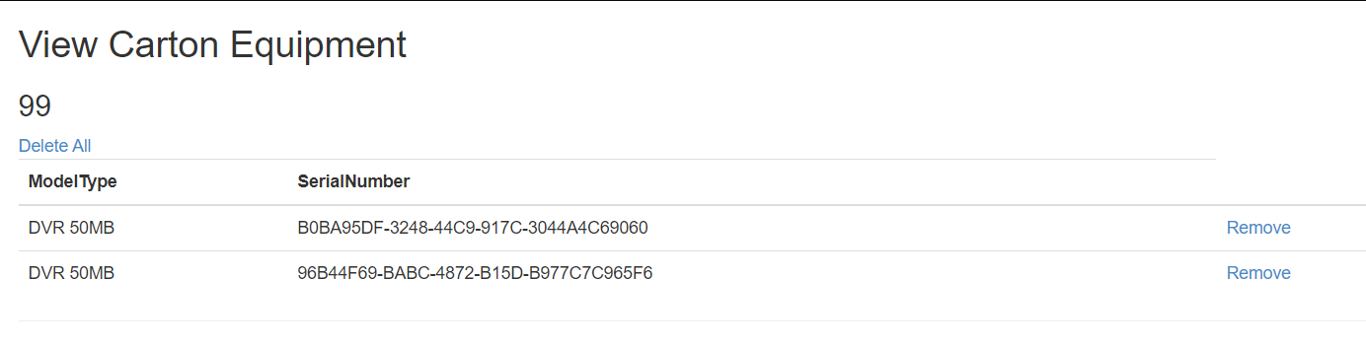

**Our customers have reported the following bugs:**  
1. We can delete empty cartons from the system, but cannot delete cartons that have items. We  
should be able to delete a carton at any time.

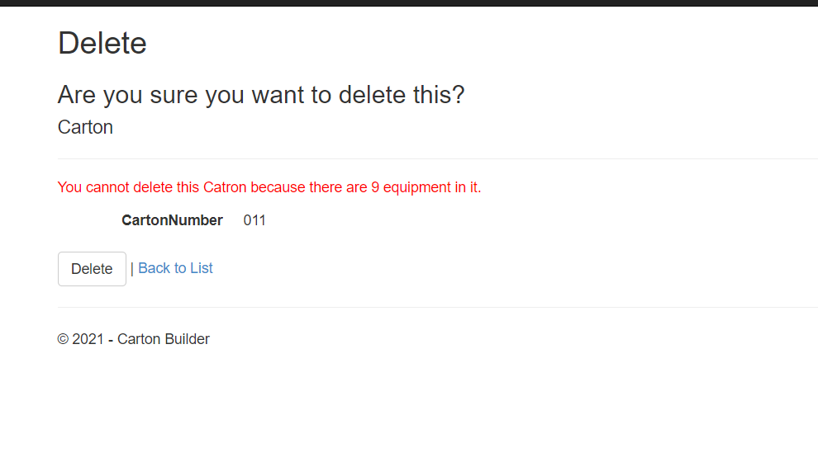

2. We can add the same piece of equipment to 2 different cartons, this doesn’t make sense. We  
should only be able to add a piece of equipment to 1 carton, once a piece of equipment is on a  
carton it should be unavailable to place on another carton.

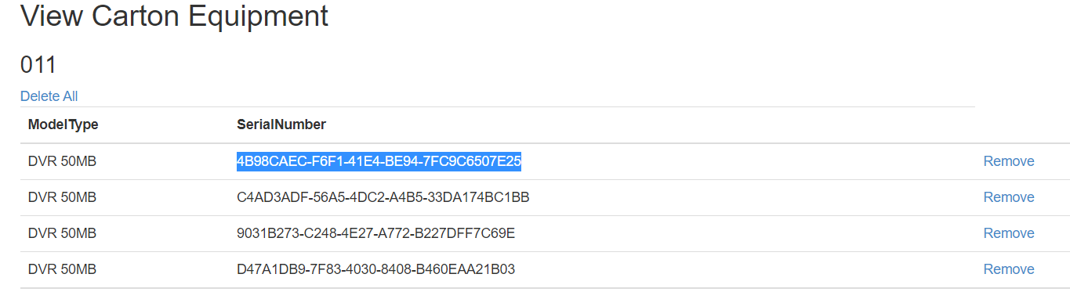

Above Added equipment did not find another carton.

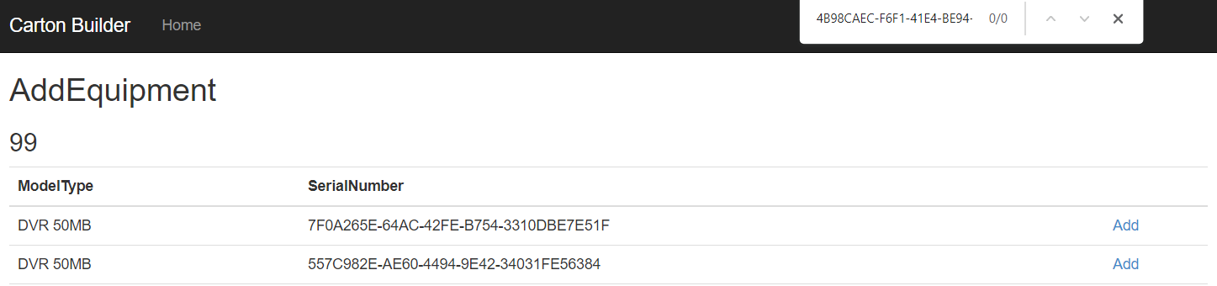

**3. Our cartons can physically hold up to 10 pieces of equipment, but the application allows us to  
put an unlimited amount of equipment on the carton, please only allow up to 10 pieces of  
equipment on the carton.**

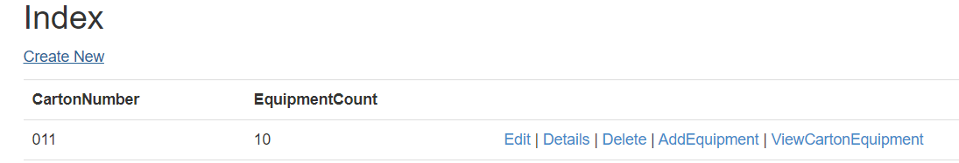

When we add any Equipment to such CartonNumber which have 10 count,it’s shows such error:

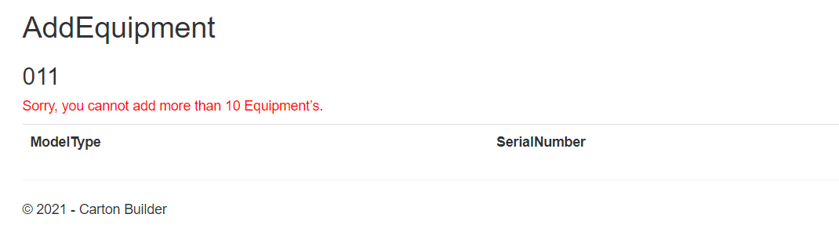

**Our customers have asked for the following enhancements:**  
1. The carton index screen should show the # of pieces of equipment on the carton.

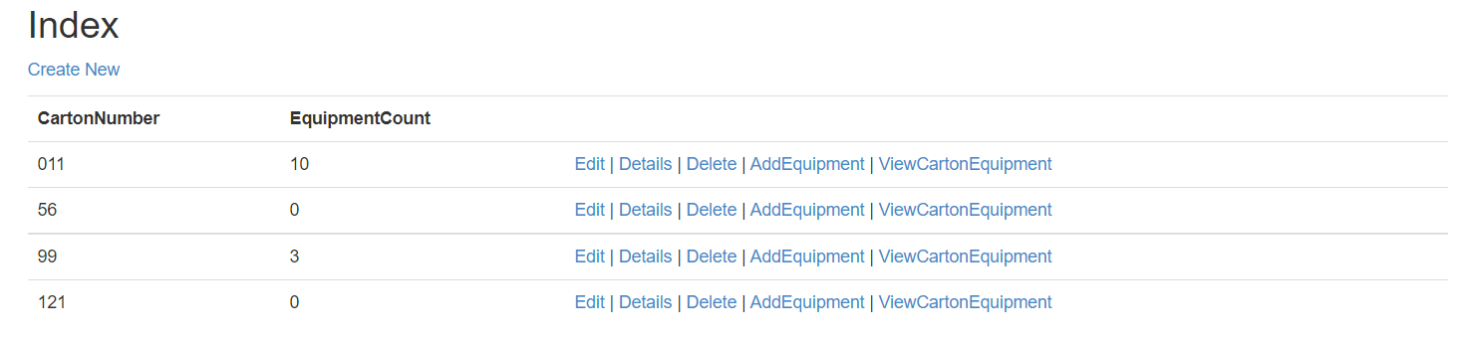

**2. We need a quick way to remove all the items from the carton with 1 click.**

**Note:** When we click on Delete All button, it shows following popup and then delete all Equipment. PFB screen print as a reference.

